

Android Club Activity Report

**Android club 2017-2018**

**Meghna Lohani**

**16BCE1395**

# COUNT

An application with a button to increment to count , a button to reset to zero and a button to display a toast

Screenshots:

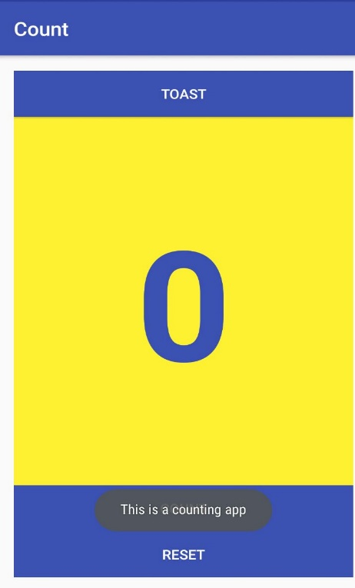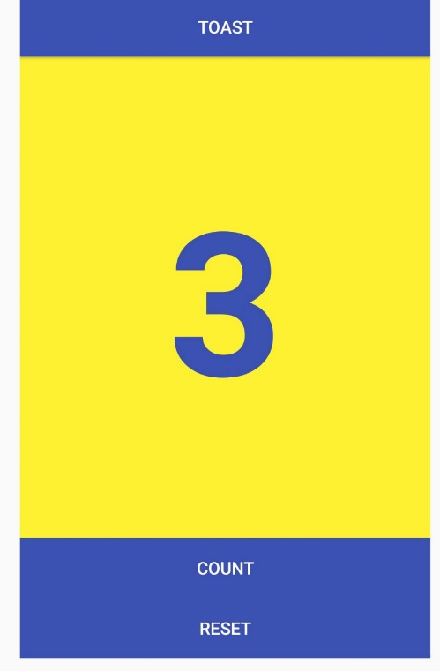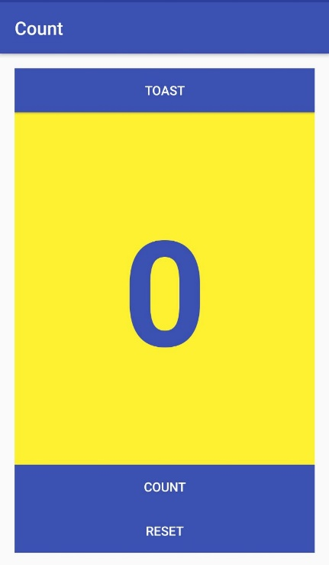

Source Code :

## Implicit intents

An app with one activity and three options for actions: open a web site, open a location on a map, and share a snippet of text. All of the text fields are editable (EditText), but contain default values.

## Receive data

An app which fetches data from a JSON server.

(Demo video already uploaded on group)

## TWo activities

An app which implements the use of intents. It sends data from one page to another.

## four week android course on coursera

## 

50 OBJECTIVE TYPE QUESTIONS ON ANDROID

ADD TO CALENDAR

A simple app using intents to add events directly to calendar.

## KEYBOARD SAMPLES

This app changes the input keyboard so that it suggests spelling corrections and capitalizes each new sentence, and displays the entered text in a toast message

Source Code:

## phone number spinner

This app provides a spinner for setting a label for a phone number. The user taps the phone number field to enter a number, and then taps the spinner to assign a label. The text field at the bottom of the screen shows the phone number and spinner label. The optional Show button also shows the phone number and spinner label.

## date time pickers

This app shows the date and time pickers. The user taps Date to set the date in the date picker, and after changing the date, the main screen shows a toast message with the date. The user taps Time to set the time in the time picker, and after changing the time, the main screen shows a toast message with the time.

## droid cafe

Droid Cafe lets a user tap image buttons to launch an activity, and choose a delivery option from radio-button choices for a food order. It includes the options menu with choices that display a Toast message showing which choice. It also includes an implicit intent to launch the Maps app when the user taps the floating action button.

## Recycler view

This sample shows how to use a RecyclerView to display data using a custom adapter to manage the data and the views.

## scorekeeper

The Scorekeeper application keeps score for any game involving two teams. The user can increment or decrement the score for each team using simple Button views.

## convert miles to km

An app which takes input in km and displays the result in miles or vice versa.

## notify me

The Notify Me! app delivers a notification in response to a button click. The notification has the ability to update itself with a picture as well as cancel itself using notification actions.

## alarm manager-the stand up!

The Stand Up! Application uses the AlarmManager to schedule an inexact repeating alarm that delivers a notification to remind the user to stand up, approximately every fifteen minutes.